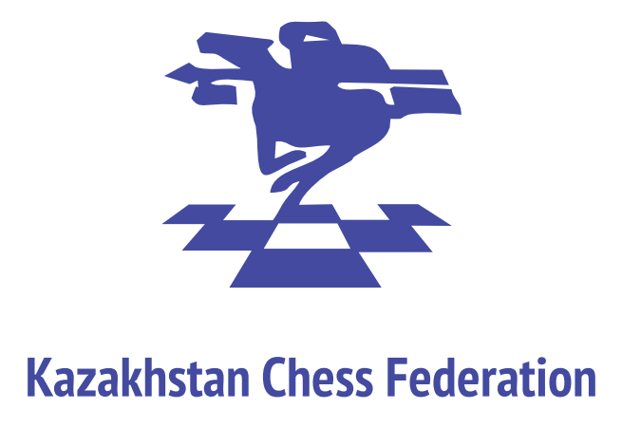
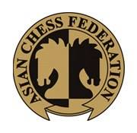
Asian Continental Chess Championships
(Open and Women’s Championships)
3rd June – 12th June 2023, Almaty, Kazakhstan
To All FIDE Affiliated Chess Federations in Asia
Zones 3.1, 3.2, 3.3, 3.4, 3.5, 3.6 & 3.7

All Kazakhstan Chess Federation on behalf of the Asian Chess Federation and FIDE invites your Federation to participate in the Asian Continental Chess Championships (Open and Women’s) from 3rd June (arrival) to 12th June (departure) 2023 in Almaty, Kazakhstan. Playing venue is Baluan Sholak Sports Palace, Address: Abay Ave 44 Abai Ave., corner Baitursynuly St., Almaty.

RULES & REGULATIONS

The Championship will be played in accordance with the following rules and regulations:

ELIGIBILITY & PARTICIPATION

Each Federation from FIDE Zones 3.1, 3.2, 3.3, 3.4, 3.5, 3.6, and 3.7 can include one official player in the Open and one official player in the Women’s Championships.

In addition, each Federation may add extra players rated 2300 and above for the Open, and 2000 and above for Women based on the 1st May 2023 FIDE Rating List. Extra players will be responsible for the payment of their board and lodging through the Organizing Committee. Exceptions for the rating floor may be made by the Continental President at the request of national federations.

PLAYING CONDITIONS

  - The tournament shall be conducted as a Swiss System competition of 9 rounds and will be played according to FIDE regulations.

  - The time control is 90 minutes for the first 40 moves followed by 30 minutes for the rest of the game with an addition of 30 seconds per move starting from move one. The games shall be played with DGT clocks. Pairings will be made by the Swiss Manager Program. Players from the same federation with a more than 50% score shall not be paired together in the last round.

SCHEDULE

3rd June | Arrival | Almaty time  (GMT+6)
 | Technical Meeting | 18:00
 | Blitz Championship | 19:00
4th June | Opening Ceremony | 14:30
 | Rd. 1 | 15:30
5th June | Rd. 2 | 15:00
6th June | Rd. 3 | 10:00
 | Rd. 4 | 17:00
7th June | Rd. 5 | 15:00
8th June | Rd. 6 | 15:00
9th June | Rd. 7 | 15:00
10th June | Rd. 8 | 15:00
11th June | Rd. 9 | 10:00
 | Awarding Ceremony | 17:00
12th June | Departure

Organizers, if necessary might make changes in the schedule, after consultation with the Asian Chess Federation.

Attendance is required at the opening and closing ceremonies. The default time will be 15 minutes for each round.

REGISTRATION

The registration form shall be accessed via link https://forms.gle/4uPQhFDeqieDqXdCA and shall be submitted by the national federation on or before 21st May 2023 together with payment.

A digital ID photo and clear scanned Passport Copy of each player or accompanying person should be uploaded in the registration form and submitted to the Organizing Committee.

REGISTRATION FEE

  - Each player or accompanying person must pay US$100 to the organizers for accreditation, internal transportation, and other local organizational expenses.

  - 21st May 2023 is the registration deadline. After this date, organizers reserve the right to refuse or decline late registrations. Late registration shall bear a $50 fine.

ENTRY FEE

  - In accordance with Asian Chess Federation regulations, an entry fee of US$150 is required for each invited (official) player.
  - For each additional (extra) player, an entry fee of US$300 is required.

PAYMENTS
  - After the Registration forms for all players and accompanying persons have been filled in, sent to the Organizing Committee and approved by the Organizing Committee, the national federations will receive invoices for bank payments. The invoices will contain all the necessary details for the bank payment.
  - The payment deadline for registrations and accommodations is May 21st, 2023
  - A sender must pay all bank commissions. When payments are confirmed, the Organizing Committee will send to the participating Federation the confirmation of the hotel reservations.

TRAVELLING EXPENSES

In accordance with FIDE Regulations, travel expenses shall be borne by the participating Federations.
Organizer arranges transfer between Almaty International Airport and the official hotel.

ACCOMMODATION

  - The official hotels are Holiday Inn Express (3-stars) and DoubleTree by Hilton (4-stars). All participants and accompanying persons are required to stay at an official hotel.
  - The hotels, both located near the playing venue, offer comfortable accommodation, high-quality service, and a range of modern amenities at the rates below:

Hotel name | Distance from the playing venue | Type of room | Price
Holiday Inn Express  https://www.ihg.com/holidayinnexpress/hotels/ru/ru/almaty/alamt/hoteldetail/gallery  Address: Seifullin Avenue, 597/5 | 1.3 km  13 min by walk | Single room | 105 USD  full board
 |  | Twin room | 77 USD per person  full board
DoubleTree by Hilton  https://www.hilton.ru/hotels/doubletree-by-hilton-almaty/#overview  Address: Dosmukhamedov Street, 115 | 600 m  6 min by walk | Single room | 185 USD  full board
 |  | Twin room | 140 USD per person  full board
The tourist fee (bed tax) for foreigners in the amount of 5% of the cost of stay per day will be additionally added to the hotel rates.

  - The official players from each National Federation will be provided with lodging from the afternoon of 3rd June till noon of 12th June 2023.

  - Each extra player/accompanying person should pay for their accommodation through the Organizing Committee in advance.

PRIZES

  - Total prize fund is $100,000 (pre-tax), including Open, Women and Blitz as follows. Local tax is 20%.

 | Open | Women | Blitz Open | Blitz women
1st place | 10 000 | 8 000 | 3000 | 2000
2nd place | 8 000 | 6 000 | 2000 | 1000
3rd place | 7 000 | 5 000 | 1000 | 700
4th place | 6 000 | 4 000
5th place | 5 000 | 3 000
6th place | 4 000 | 2 000
7th place | 3 000 | 1 500
8th place | 2 000 | 1000
9th place | 1 500 | 700
10th place | 1000 | 700
11th place | 700 | 700
12th place | 700 | 700
13th place | 700 | 700
14th place | 700 | 500
15th place | 500 | 500
16th place | 500 | 500
17th place | 500 | 500
18th place | 500 | 500
19th place | 500 | 500
20th place | 500
Total | 53 300 | 37 000 | 6 000 | 3 700
Prizes shall be shared among tied players.

  - The top four (4) from the 2023 Asian (Open) Championship shall qualify for the 2023 World Cup and the top two (2) from the 2023 Asian Women’s Championship shall qualify for the 2023 Women’s World Cup.

CHIEF ARBITER AND HIS ASSISTANTS

  - The Chief Arbiter, his Deputy and Assistants will be appointed by the Asian Chess Federation President, Sheikh Sultan bin Khalifah Al Nahyan. Any matter not mentioned in these regulations shall be decided upon, if necessary, after consultation with the Asian Chess Federation.

  - A Technical Delegate, to be appointed by the Asian Chess Federation president, shall be responsible to ensure that the Organizing Committee adheres strictly to both the general conditions and the regulations of the Asian Continental Championship.

APPEALS COMMITTEE

  - An Appeals Committee shall be constituted before the beginning of the tournament as stipulated in the regulations.

  - There shall be a Chairman, two members, and two reserve members shall from different Federations, appointed by the ACF President in consultation with the Organizing Committee. No member of the Appeals Committee shall sit in judgment in a dispute involving a player or party from his Federation except where the dispute is between two players or two parties from his Federation.

  - All protests must be submitted in a written form to the Appeals Committee not more than one hour after the relevant playing session, or the particular infringement complained against.
  - The appeals process shall include written representations and a written decision. The Committee shall endeavor to find binding solutions that are within the true spirit of the FIDE motto. Each protest must be accompanied by a deposit fee of USD 200 (two hundred US Dollars) or the equivalent in local currency. If the protest is accepted, the fee shall be returned. If the protest is rejected, the fee may be forfeited to the Organizing Committee. The written decision of the Appeals Committee arising from any dispute in respect of these regulations shall be final.

TIE BREAK

  - Tie break system to make ranking will be calculated in the following order:
- Average Rating of Opponents Cut 1 (AROC 1)*
- Buchholz Cut 1**;
- Buchholz;
- Direct encounter between the players in tie;
- Drawing of lots.
* Average Rating of Opponents, excluding the lowest-rated opponent.
** Buchholz score reduced by the lowest score of the opponents.

VISAS

All players and accompanying persons who require a visa to enter Kazakhstan must send a copy of passport (page with photo and key information), a registration form (attached) and a passport size photo to the Organizer before the deadline of 21st May 2023 for extending visa invitation after which the Organizer shall not be responsible.
The invitation letter will be sent after the payment is done.

DRESS CODE

All Players are obliged to wear uniforms that represent their national federation and/or the national flag. Shorts and slippers, sunglasses, sport caps and revealing attire are not allowed. Award winners should follow the dress code at the closing ceremony.

CONTACTS

If you have any questions, please refer to the following contacts:
Yernur Sovetkali  Tournament coordinator | +7 708 818 00 07  play@kazchess.kz
Gulmira Dauletova  Executive director/organizer | director@kazchess.kz
Darmen Sadvakasov  Tournament director | the.darmen@gmail.com

