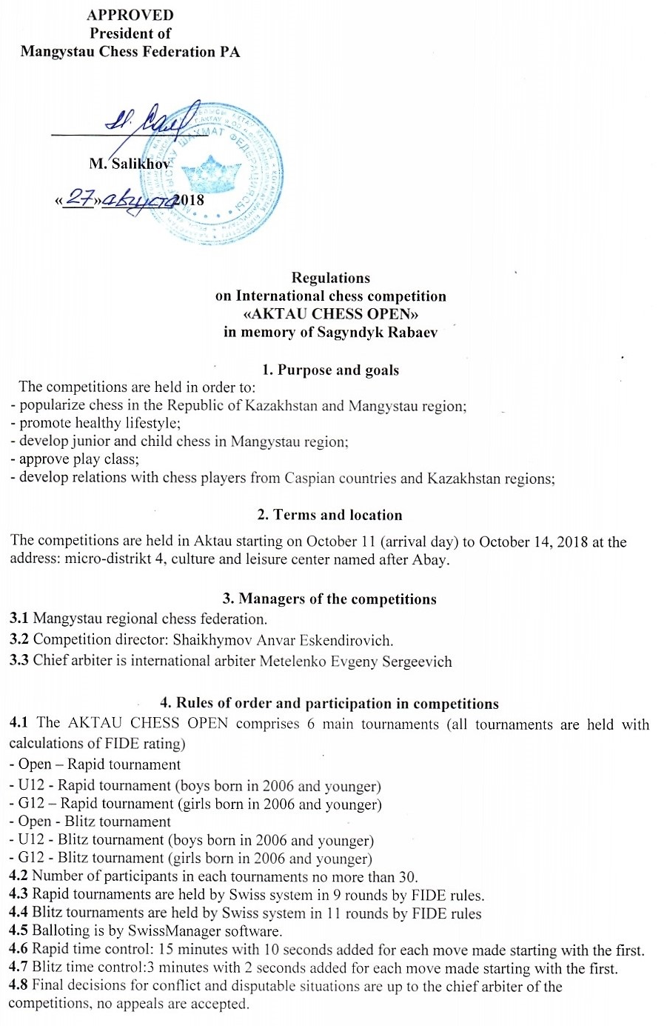

4.9 Tournament schedule:
 | Open, U12, G12 tournaments
October 11 | Arrival day  10:00 - 14:00 Registration;  15:00 opening ceremony;
October 12 | Open Tournament - Rapid  U12 Tournament - Rapid Start at 10:00, 1-4 tours  G12 Tournament - Rapid
October 13 | Open Tournament - Rapid  U12 Tournament - Rapid Start at 10:00, 5-9 tours  G12 Tournament - Rapid
October 14 | Open Tournament - Blitz  U12 Tournament - Blitz Start at 10:00, 1-11 tours  G12 Tournament - Blitz
October 14 | 15:00  Awarding and closing ceremony.

5. Tournament fees
Participation in both tournaments is mandatory and is covered by a single fee
No | Competition name | Free
 |  | Rating | Sum, KZT
1 | Open Rapid + Open Blitz | IM and higher  2300< | No fee
 |  | All others | 15,000
2 | U12 Rapid + U12 Blitz  G12 Rapid + G12 Blitz | - | 15,000
 |  | - | 15,000
Tournament fee for non-residents is 50 USD
Residents of the Republic of Kazakhstan transfer their tournament fees (according to their FIDE rating), no later than September 25 2018 to the account below.
Bank names | JSC Halyk Bank
Account | KZ196010002005302518
Name of recipient | Shaikhymov Anvar
IRN | 870127302126

Non-residents of the Republic of Kazakhstan transfer their tournament fees in US dollars (according to their FIDE rating), no later than September 25 2018 to the account below:
Bank names | JSC Halyk Bank, SWIFT/BIC:HSBKKZKX
Correspondent Bank in USD | The Bank of New York Mellon., New York, USA,  SWIFT/BIC: IRVTUS3NXXX
Account | KZ676018353000002044
Last Name | Edilova Gulbanu

Tournament fees are spent for organization of the tournament.

6. Winner declaration. Awarding
6.1 Winners of the competitions are determined by the largest sum of points of all matches.
If the points are equal, the winner is determined by (in sequence):
а) results of personal match (if all participants in question have had a match with each other);
б) Buchholz ranking;
в) more won matches;
г) truncated Buchholz ranking without worst result;
д) largest number of matches played by black;
6.2 Main and additional prizes are not dividable. A participant can ony obtain the largest award.

Awards and nominations

Open Rapid tournament
1 award - 200 000 KZT | 2 award – 120 000 KZT | 3 award - 80 000 KZT
- best result among women - 20 000 KZT
- best result in children born in 2000 and younger - 20 000 KZT

Open – Blitz tounrnament
1 award - 100 000 KZT | 2 award - 60 000 KZT | 3 award - 40 000 KZT
- best result among women - 20 000 KZT
- best result in children born in 2000 and younger - 20 000 KZT

U12 Rapid tounrnament
1 award - 100 000 KZT | 2 award - 60 000 KZT | 3 award - 40 000 KZT
- best result in children younger than 10 y.o. - 20 000 KZT
- best result in children younger than 8 y.o. - 20 000 KZT

U12 Blitz tounrnament
1 award - 50 000 KZT | 2 award - 30 000 KZT | 3 award - 20 000 KZT
- best result in children younger than 10 y.o. - 10 000 KZT
- best result in children younger than 8 y.o. - 10 000 KZT

G12 Rapid tounrnament
1 award - 100 000 KZT | 2 award - 60 000 KZT | 3 award - 40 000 KZT
- best result in children younger than 10 y.o. - 20 000 KZT
- best result in children younger than 8 y.o. - 20 000 KZT

G12 Blitz tounrnament
1 award - 50 000 KZT | 2 award - 30 000 KZT | 3 award - 20 000 KZT
- best result in children younger than 10 y.o. - 10 000 KZT
- best result in children younger than 8 y.o. - 10 000 KZT

7. Expenses for running the competitions
7.1 The Mangystau regional chess federation and organizers provide and cover the following expenses: lease of venue, payment of awards;
7.2 All expenses of the participants are covered by their sending organizations.
7.3 Every national federation has the right to send one official command. The commands must include three chess players: 1 player in Open tournament (level at least of FIDE Master), 1 player (U12), and 1 player (G12). The hosts pay for accommodation and meals (breakfast and dinner) of such official commands. Additional commands can be sent, but their expenses are covered by their sending organizations.

8. Receiving applications and additional information
8.1 The applications should be sent to e-mail address
aktau.chess.school@bk.ru
The application which complies with the form (Appendix А), passports, scans of document evidence for payment of the fees bearing seals of the sending organizations must be sent before September 25. 2018
8.2 The Organizational committee reserves the right to refuse applications submitted after the set date.
8.3 Contact phones:

Shaikhymov Anvar Eskendirovich  Director of competitions | +7 702 598 2009
Meteleno Evgeny Sergeevich  chief arbiter, international arbiter | +7 771 856 4853
Gabdushev Arman Amangeldiyevich  Ch. secretary, FIDE arbiter | +7 771 276 3065
Shilterhanova Uriya  specialist on organizational issues | +7 707 472 7472

APPENDIX A
Application
for participation in the International chess competition
AKTAU CHESS OPEN in Aqtau
from _______________________________
contact number: __________________________________

No | Full name | Sex | Year of birth |  | Rank/class | City/region | Match | Coach

Contact person: __________________

